**Gracious Germents**

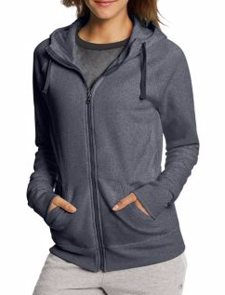

**DESCRIPTION:**

Champion Women’s Fleece Full Zip Hoodie

Champion

Authentic

W0933

Units per Pack:1

Units Per Pack: 1

Fabric Content: 100% Polyester

Country of Origin: Imported

**ADDITIONAL INFORMATION**

Weight: 0.5 kg

Dimensions: 10 × 8 × 3 cm

Size: S, M, L, XL,

Price: $20.00